

RESTORING THE PRESUMPTION OF INNOCENCE

**Conference Program**

**Saturday 31 August 2024 | Rushcutters Bay, Sydney**

**presumptionofinnocence.au**

|  |  |
| --- | --- |
| **8:30 am** | **Conference Opening** |
| **9:00 am** | **Welcome**  **Peter Deakin, KC**  *Former Barrister and Author* |
| **9:10 am**  **9:30 am**  **10:00 am**  **10:30 am** | **Celebrity’s #MeToo Attack Mystery speaker**  **Men under siege Bettina Arndt AM**  *Social commentator, men’s issues activist*  **Domestic Violence Orders Violate Human Rights Professor Augusto Zimmermann**  *Law professor and former WA Law Reform Commissioner*  **Q&A** |
| **10:45 am** | **Morning Tea** |
| **11:15 am**  **11:45 am**  **12:05 pm**  **12:25 pm** | **The verdict goes to….the best actress Zali Burrows**  *Sydney criminal Lawyer*  **Trial By Media Damian Coory**  *Journalist, Host of ‘The Other Side’ on YouTube.*  **Punished for False Allegations Ian Jones**  *The father who had his son’s accuser sent to prison*  **Q&A** |

|  |  |
| --- | --- |
| **12.45 pm** | **Lunch** |
| **1:30 pm**  **1:50 pm**  **2:10 pm**  **2:30 pm**  **2:45 pm** | **True rates of domestic and family violence in Australia**  *Founder of* [*www.****oneinthree.com.au***](http://www.oneinthree.com.au/)  **Male Victims of Coercive Control**  *Release of new video*  **False Rape Allegations Aren’t So Rare Tom Nankivell**  *Expert in statistical analysis and public policy*  **Faking the Stats**  *Video on feminist lies, damned lies and statistics*  **Q&A** |
| **2:55 pm** | **Afternoon Break** |
| **3:10 pm**  **3:35 pm**  **3:45 pm** | **My Son Was Found Not Guilty Dr Debbie Garratt**  *Clinical supervisor, son falsely accused of sexual assault.*  **Q&A**  **ASF Panel Discussion on the Presumption of Innocence**  **Dave Richards, Jan Health, Alex Hatzikalimnios, Sienna Baker.** |
| **4:15 pm**  **5:00 pm** | **Call to Action**  How do we achieve fairness for accused men?  **Nadine Taylor**  *Family Law Consultant. Former UK campaign director for Fathers4Justice*  **Plus Bettina Arndt with and other key strategists discuss exciting new Australian initiatives** |
| **Conference Close** |

**Thanks to…**

Damn Good Productions | Naughtee Design | Insight Films

| TNT Radio | Coral Creative | MedalTally Brand & Packaging Design

**Event Sponsor Event Host**



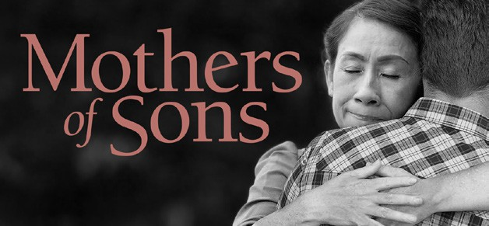

**presumptionofinnocence.au**